Lesson 22: Billboard

1.LCD1602:
LCD1602, or 1602 character-type liquid crystal display, is a kind of dot matrix module to show letters, numbers, and characters and so on. It's composed of 5x7 dot matrix positions; each position can display one character. The model 1602 means it displays 2 lines of 16 characters. The principle of LCD1602 liquid crystal display is to use the physical properties of liquid crystal to control its display area through voltage, and then display characters. (Note: The potentiometer on the back can adjust the clarity of the display)
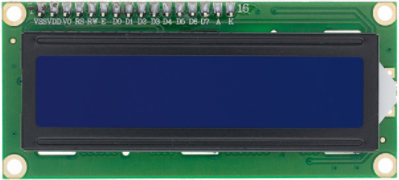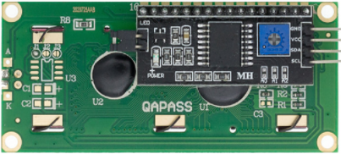

2.Project Introduction:
The first line of LCD1602 scrolls from right to left to display the string of "Hello Pico", simulating the effect of billboard scrolling.
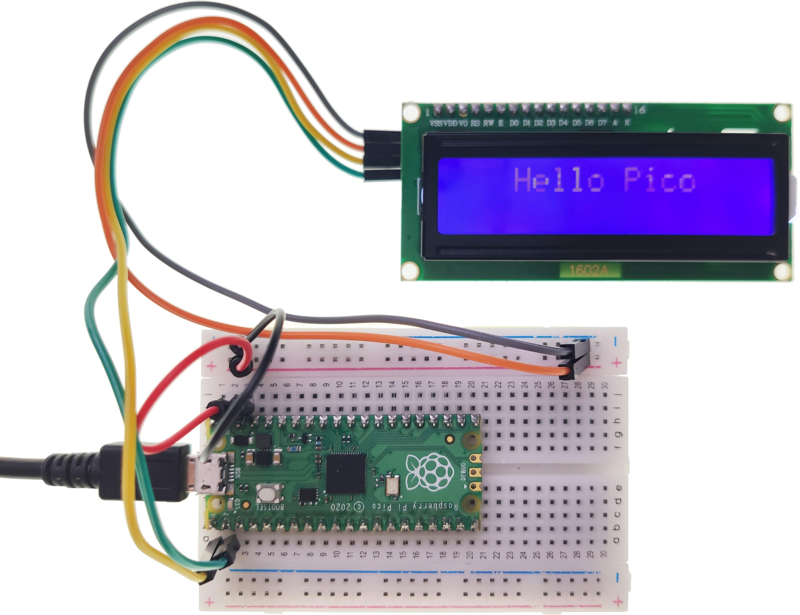

3.Circuit connection:
3.1 Material preparation: Raspberry Pi Pico*1, USB able*1, Breadboard*1, LCD1602*1, Dupont line;
3.2 Port connection:
Raspberry Pi Pico | LCD1602
GP0 | SDA
GP1 | SCL
VSYS | VCC ( + )
GND | GND ( - )

4.Library file installation:
Upload the “lcd_api.py” and “i2c_lcd.py” library file to the Raspberry Pi Pico. For the specific operation steps, please refer to Lesson 16.

5.Program analysis: Billboard
from machine import I2C, Pin
from i2c_lcd import I2cLcd
from utime import sleep

DEFAULT_I2C_ADDR = 0x27 # LCD 1602 I2C address
# If 0x27 doesn't respond then 0x3f is used
i2c = I2C(0,sda=Pin(0),scl=Pin(1),freq=400000)
lcd = I2cLcd(i2c, DEFAULT_I2C_ADDR, 2, 26) # Initialize(device address, cursor settings)
text = ' Hello Pico' # Show scrolling information

if __name__ == '__main__':
while True:
tmp = text # Get the display information
for i in range(0, len(text)):
lcd.move_to(len(text),1) # Position cursor
lcd.putstr(tmp) # Display one by one
tmp = tmp[1:]
sleep(0.8)
lcd.clear() # Clear display

